**[1]Thought Spot in a Nutshell**

**27-Feb-2022**

# OBJECTIVE:

* Provide user the experience of Google search like UI experience to generate Business Intelligence Insights
* In Short, “Search in AI Driven Analytics”

# ACRONYMS/KEYWORDS

TSL : THOUGHTSPOT SCRIPT LANGUAGE

UBR : USER BASED RANKING

YAML : YET ANOTHER MARKUP LANGUAGE

JIT : JUST IN TIME (FOR DATABASE PERFORMANCE)

SPOT IQ: AI BASED SUGGESTION ENGINE

SEARCH IQ: GOOGLE LIKE SEARCH OPTION TO GENERATE REPORT

FALCON: COLUMNAR IN MEMORY DATABASE

COLLASUM: CONVERTS SEARCH TO QUERY

INDEX :

SEARCH : PROVIDE SUGGESTION RUN TIME BASED ON COMPUTATION (NOT BASED ON DOCUMENTATION OR HISTORY LIKE GOOGLE)

DATA: HANDLES THE STRESS OF JOINS IN THOUGHTSPOT AND INDEXES IT TO IMPROVE PERFORMANCE

# **Evolution Fit of Thoughtspot**

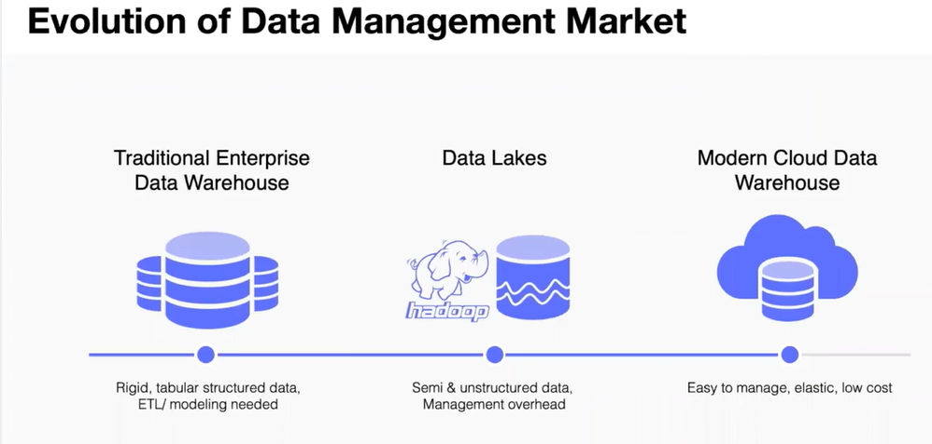

* Thought spot fits in Modern Cloud data warehouse

# **Architecture (High Level)**

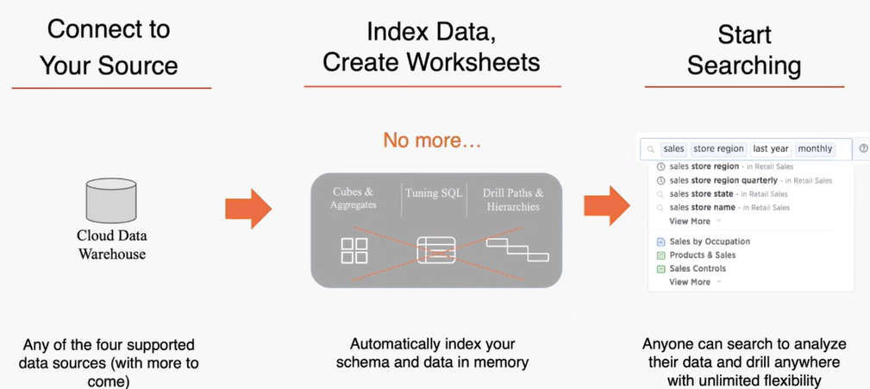

# **Architecture (More details)**

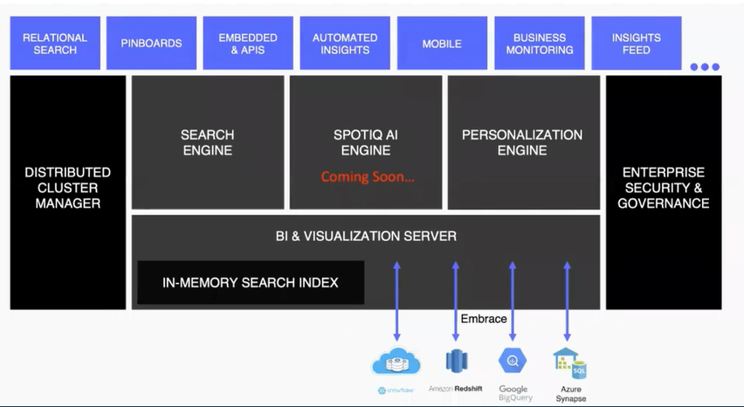

* **NOTE:**
* For Onprem, it is a cache In-memory database.
* For Cloud, it is not a cache it is an **index search**
* **Falcon** is the Underlying Database which is used for both On-prem and cloud support database
* This is utilized for better performance as if the data is residing in Thought spot

# **Life of a Search Query:**

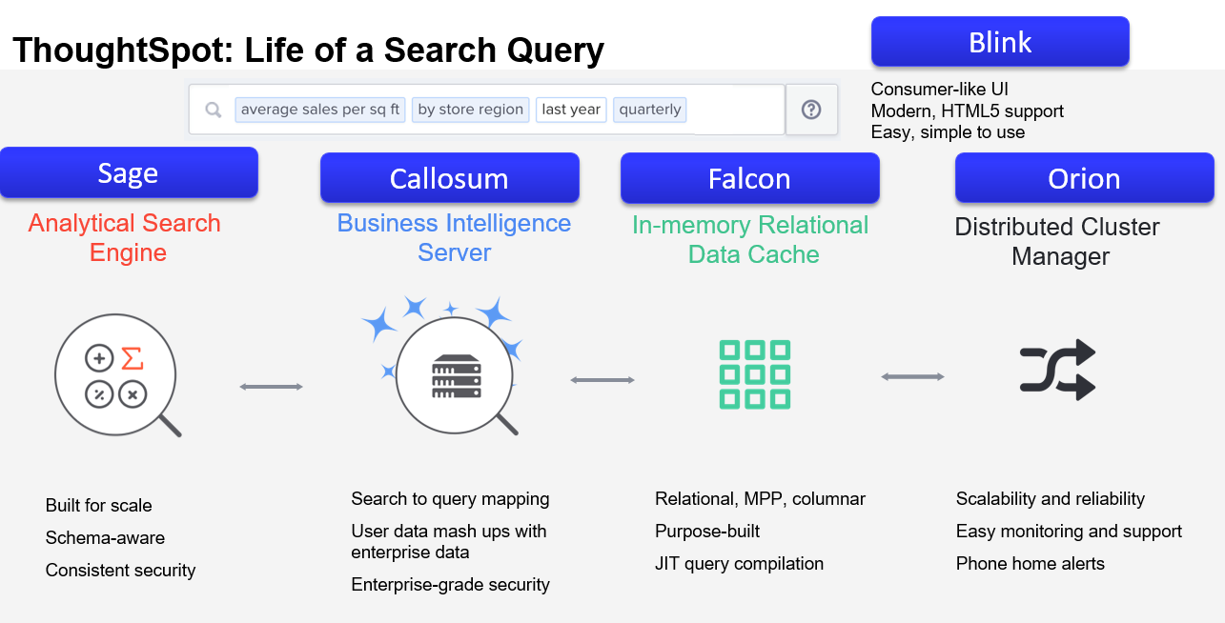

## **About the components:**

* **Sage-Analytical Search Engine:** build to scale, aware of the schema/data source, security enabled

*When is it used? When we enter search, we can search by values “MN-Minnesota state” or “MN”-Mnemonic code column. The search Engine use “computational Search index” in connection with underlying In-memory database to produce suggestions run-time based on UBR (User based ranking)*

* **Callosum-BI Server:** Take the natural language search and generate the query

*Callosum: part of the mind that connects left and right brain*

*When is it used? It primary function is to convert search to a query that database can understand and apply RLS (Row level security) to ensure the data pulled in is what the user is authenticated to see.*

* **Falcon-Relational MPP Columnar:** In memory Database cache,JIT (Just in time) Query compilation. In database, database index is used to reduce the stress of joins on performance.
* For Onprem , it is a cache In-memory database. For Cloud, it is not a cache it is an index search
* Visualization layer : comes to play to determines which type of charts to pull in based on the measure and dimension pulled in the search

*What is JIT?*

*Just-in-Time (JIT) compilation is the process of turning some form of interpreted program evaluation into a native program, and doing so at run time. For example, instead of using general-purpose code that can evaluate arbitrary SQL expressions to evaluate a particular SQL predicate like WHERE a.col = 3, it is possible to generate a function that is specific to that expression and can be natively executed by the CPU, yielding a speedup.*

* **Orion-Distributed Cluster manager:** manages everything to ensure High availability of the services. When one service go down, other is brought up
* **Connectivity to the source:** use JDBC connection to the cloud based database

# Features:

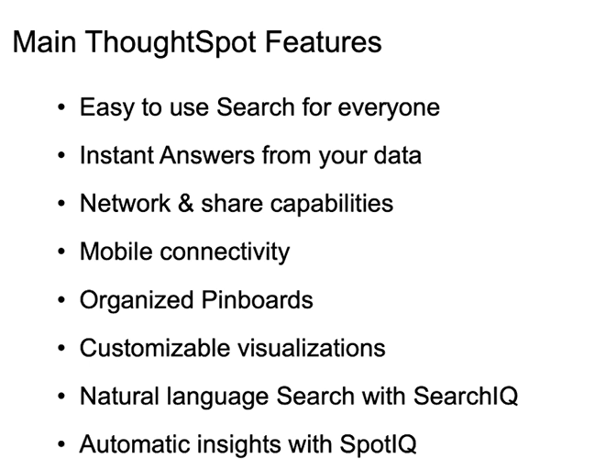

*Easy to Scale and Elastic

# 1. User INTERFACE: COMPONENTS

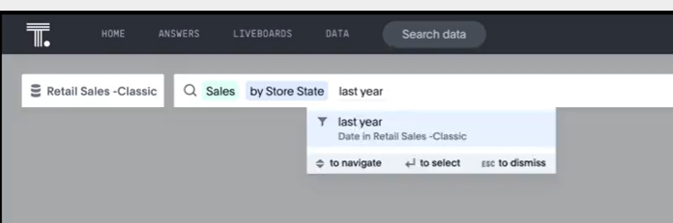

* **Search**: Which can connect to a schema/source and perform search on
* **Answers**: Saved Search
* **Live boards/Pin boards** : Dashboard that has collection of Answers
* **Data** : To establish connection to a source
* **Spot IQ** : suggest insights based on the Analysis of end to provide suggestion that we have not thought about

**–We can use the bulb sign to analyze the data to get insights**

* Results of above Analysis below

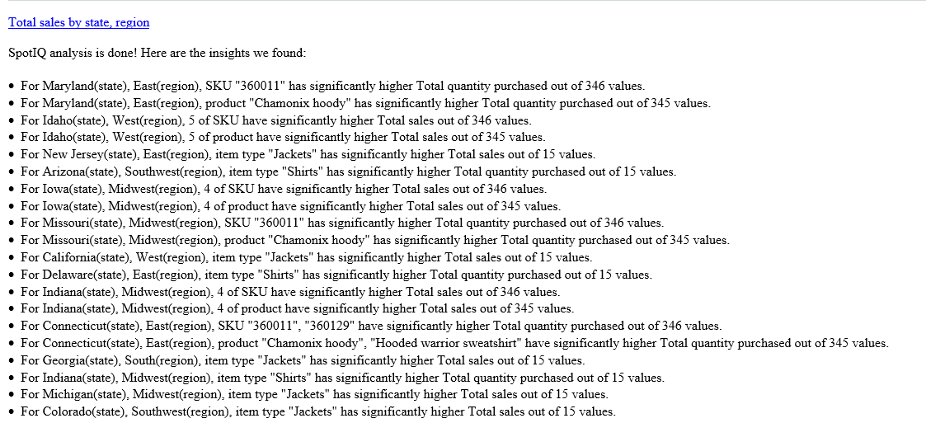

## **UI: Answers**

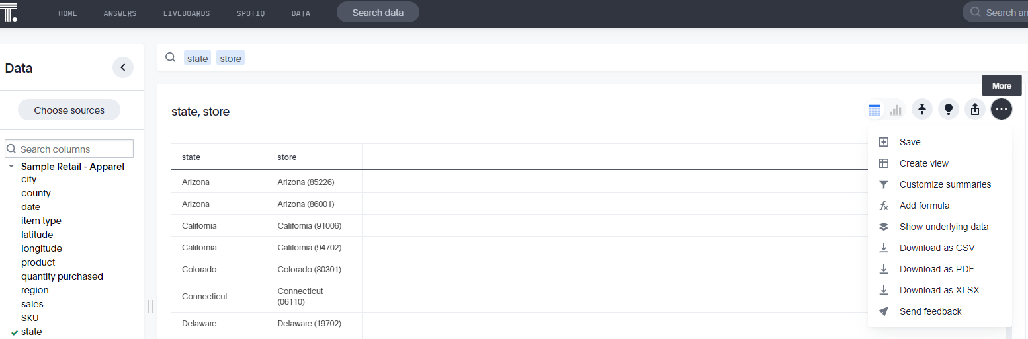

* Can add formula in worksheet or answers
* **Order of search:** Measure –Dimension-Filter
* **Customize summary :** This option adds Tiles based on the fields selected
* **Create view –** results of search can be used as source for other search

### **How to Pin KPI > WatchList**

1. Search for Measure
2. Pin Column Summary in footer, Not the table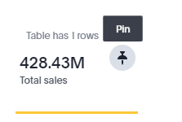

### **How to see report query**

Select “i”

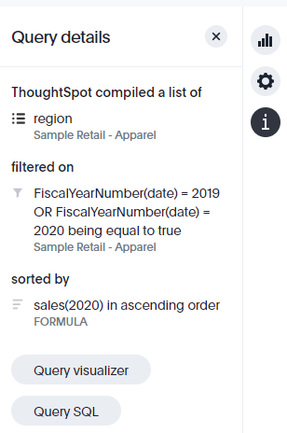

### **Filters**

* Many ways to apply Filters

### **Time & Date Filters**

**Objective:**

* Time interval : hourly, daily, etc.,
* Time buckets : Day of the week, Month of the year
* Time ranges : between, **last** month, **next** year, a day **ago**,
* Absolute/dynamic values
* Date keywords : Growth(shows % of increase), YOY, **This** day,

## **UI: DATA**

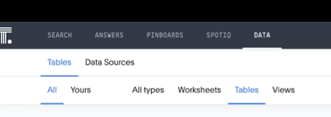

### **Types of Data Sources**

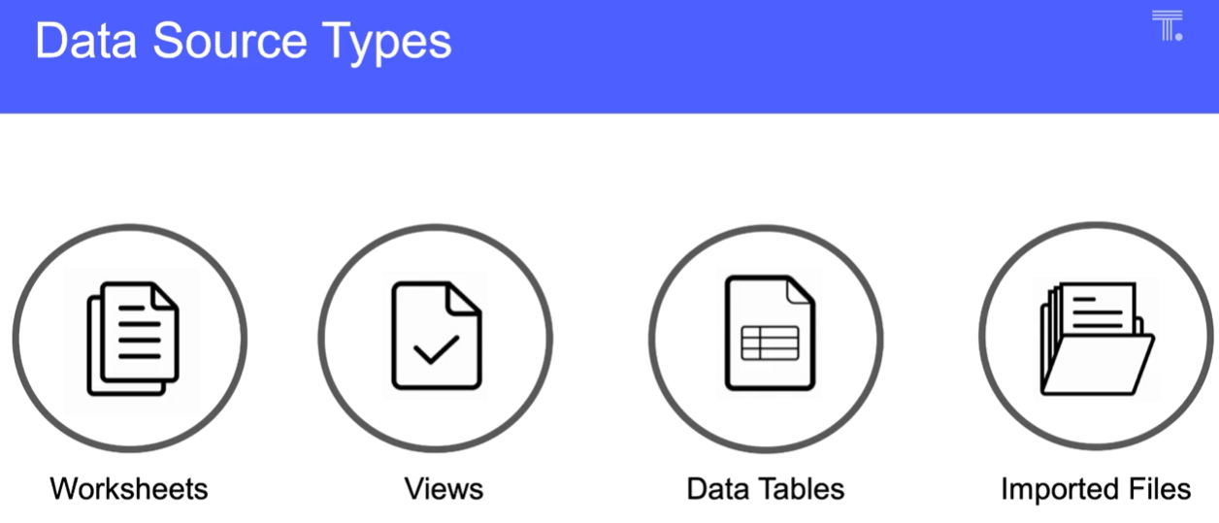

* **Worksheets**:
  + - Join one or more tables using joins and set up a data model;
    - Always start join from fact and then move to dimension
    - Chasm trap and Fan trap are auto handled in the data model (if any tables needs to be a exempt, this can be setup)
    - If no Index priority is setup, all fields go through UBR to come up in the search
    - Synonyms : If a field “product” need to be identified as “item”, more than one synonym can be setup “item”, “name”, etc..

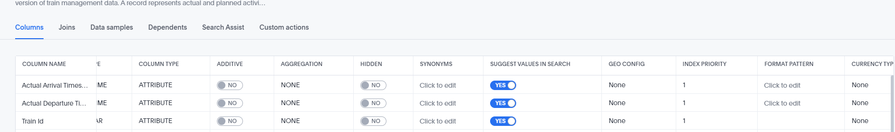

* **View**: where the search can be saved as source and we can build search on top of the search
* **Data tables** : raw tables
* **Imported tables**: Files imported into Thought spot

### What we have in Cloud?

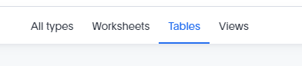

## DATA NOTE

1. Cannot use excel in Thought spot cloud
2. Data sync through **“DATA FLOW” (ETL Tool of On prem thought spot)** is used to push data from any source to Falcon in on-prem Thought spot. With Cloud, we need to use Embrace/connection to create link to the external database
3. In case of snowflake, snowflake virtual warehouse is used.
4. Snowflake’ share (purchased from market place) in addition to snowflake table can be accessed by Thought spot
5. Joins can be established in snowflake and if established can be brought down to Thought spot

### **Dependency**

**Order: Table > Worksheet > Answers > Pin board/Live board**

**NOTE:** We cannot delete Tables without deleting the worksheet. Base object cannot be deleted if there is dependency on it

Dependency can be viewed here

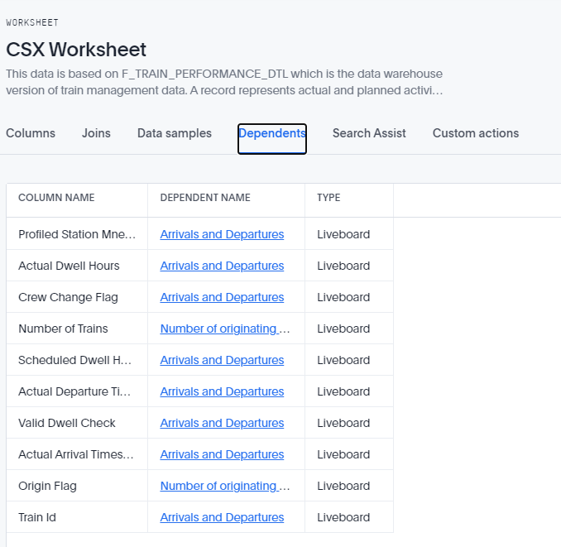

# **UI: LIVEBOARD**

## Explorer mode

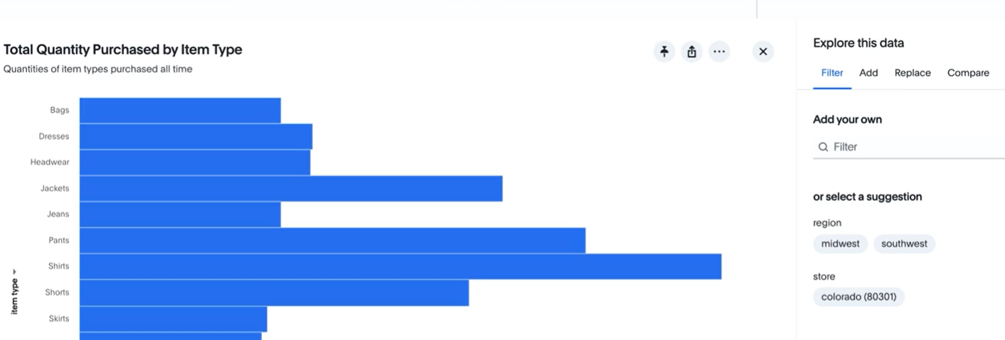

# **formula**

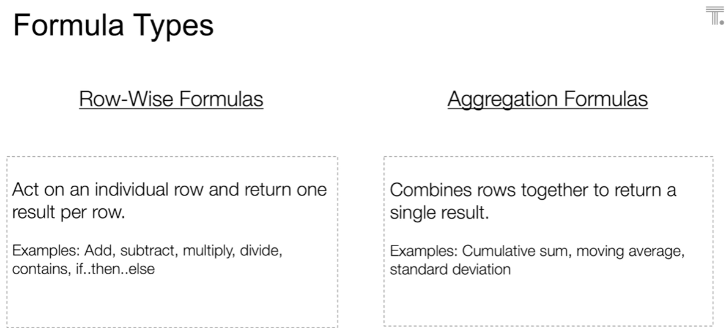

**Important (**used when we can define measure at different granularity**)**

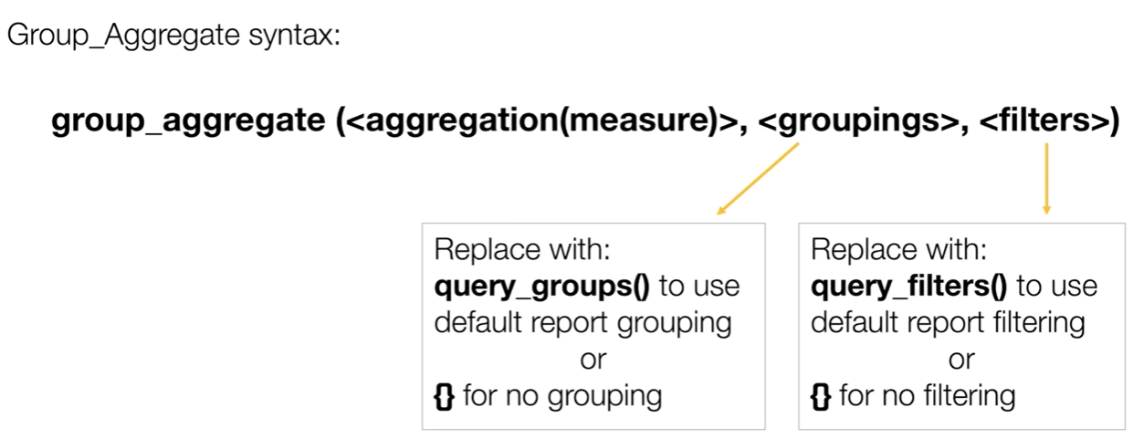

# **R Embedded in thoughtspot**

* R icon to use R as .csv or .png output
* R script can be saved as “R” templates by using eclipse icon
* Df => default data frame of thought spot
* Param (0) => refers to 1st field brought in the search; param (1) is 2nd field, so on...
* [2]#output_file# => default output file function in Thought spot

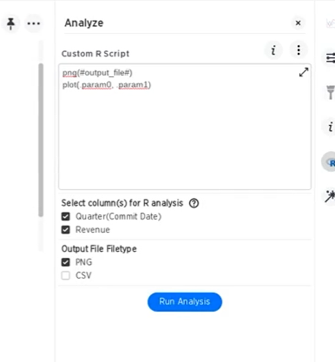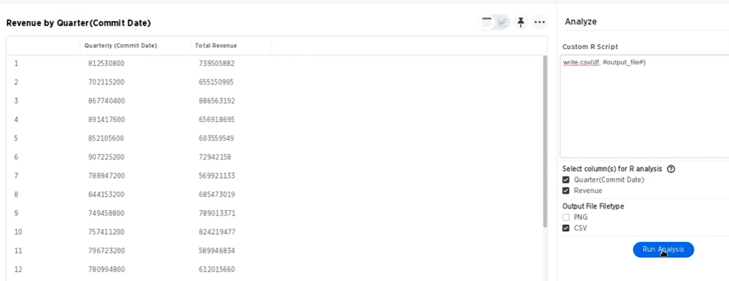

# **Sharing/Scheduling**

* Share answers with users or groups
* Schedule dashboard based on gating condition
* 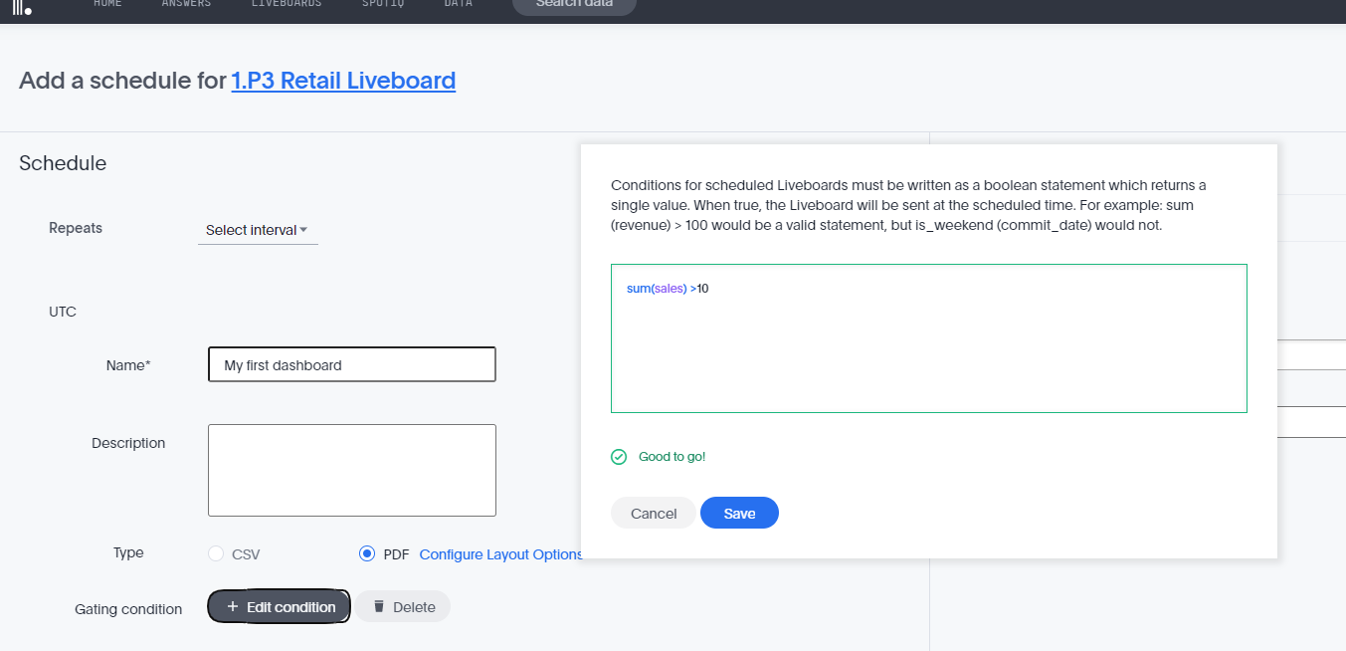

# **Scriptability**

1. You can download worksheets, answers and pin boards as editable TSL (Thought spot Script language) to migrate the objects from one environment to other or do bulk loading
2. While doing bulk update, you can either update formula expression or formula name and “NOT BOTH” as part of same export-import

# **Tips and Tricks**

1. **When some fields is not displayed, it might be in “Not visualized”. Go to Edit chart> Configure**

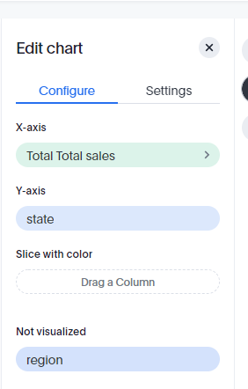

* **Limitation of data points displayed in the chart (**Default Limitation of data point(5000); max allowed is 20k.admin can pump it up to 35k)

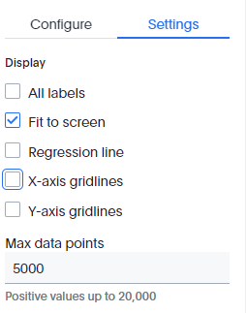

1. **Powerful .vs feature**

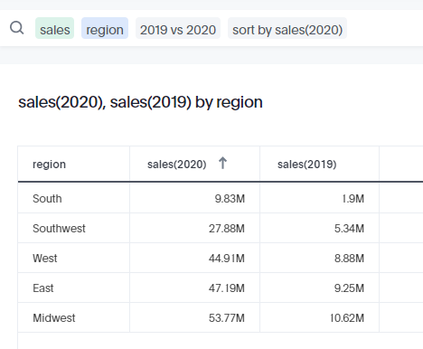

1. **Default Top/Bottom is 10**
2. **Measures in green, Dimension in blue, In calculation editor ( Fields are in purple and keywords are in blue)**

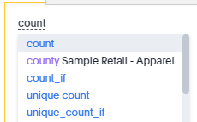

1. **Custom formatting of measure is available in Edit Chart> Configure**
2. **Multiple y-axis : use group**
3. **Use () to group multiple cities in one group and use this group to compare with other group using vs**
4. **Find New product in 2017 that did not have sales in 2016**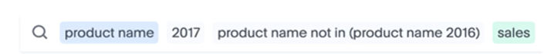

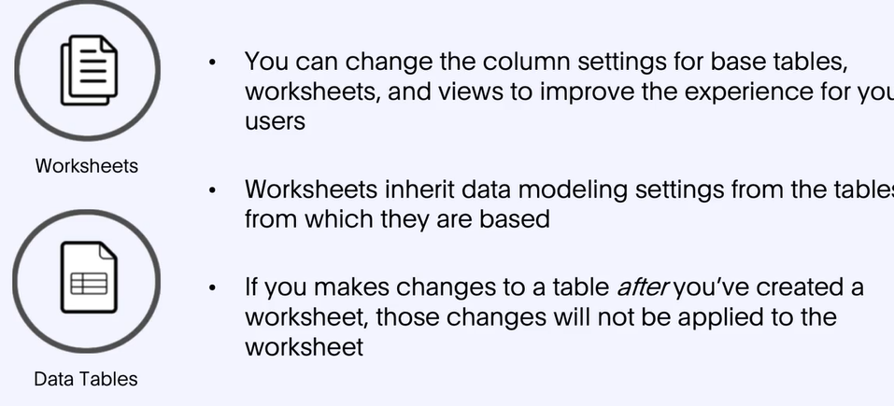

1. **Thought spot rest API can send thought spot search to Website where it can embed the results in a webpage**

# ADMIN CONSOLE

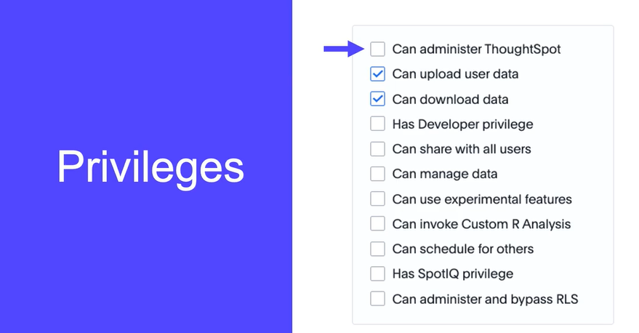

* **SAML Sign on can be enabled**

# What I cannot Find

1. Answers: Tooltip Customization?
2. How to add Total, Sub Total in a table
3. Can search as view be used as a “MV”?
4. How to create custom action
5. How to overcome limitation of 20k data points?
6. What if I want to color region by unique color?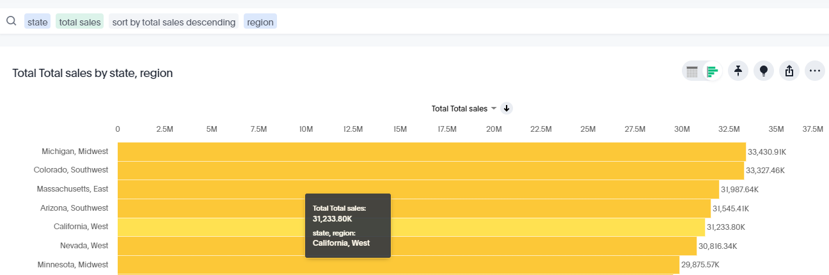
7. How to setup a new chart that is not part of the original set (Dual Axis bump chart; group charts, etc...)

Example: 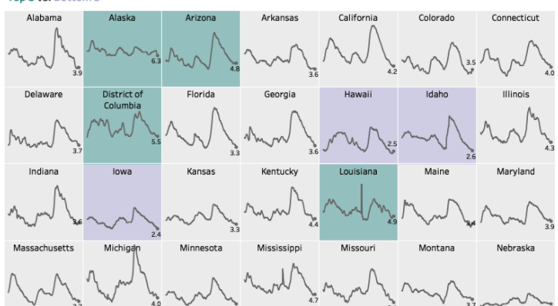 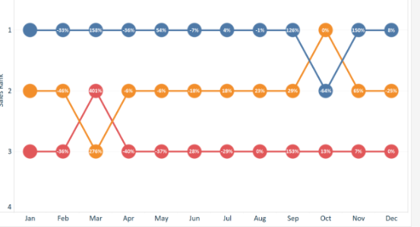

1. Simple control z or back feature : after I change the chart, cannot go back to original chart

# Features I LIKE!

1. We can display label formatting different from display formatting. Go to Edit Chart > Configure > select Measure arrow to adjust number formatting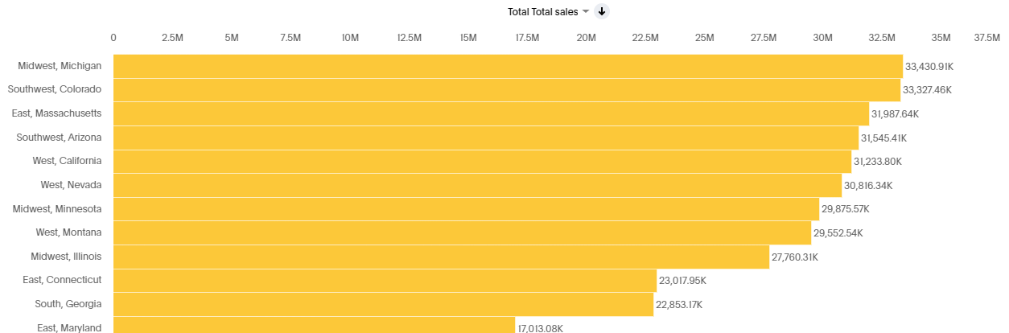
2. When the data runs for more than one page, the axis auto scales based on new data
3. ALL Feature

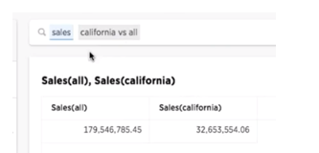

1. Unlike BOBJ, when users is part of two groups, users gets the “MOST” access
2. Quick Availability of Pareto Chart
3. Use any attribute to quickly add a filter rather than preset attributes for filter
4. Drilldown base on any column(rather than preset attribute for filter in tableau)
5. Thought spot rest API can send thought spot search to Website where it can embed the results in a webpage
6. Schedules: Pause schedule possible (tableau unsubscribe and it goes away) ; options to resume and delete is possible in Thought spot
7. Schedules: trigger the schedules when gating conditions are met

1. End of 2022 Thought Spot Analysis

   Created by Preethi Venkatesan, 27-Feb-2022
2.